 | Assignment No. 1  Semester: Spring 2026  CS201 – Introduction to Programming |  | Total Marks: 20  Due Date: 30th April 2026
Instructions
Please read the following instructions carefully before submitting the assignment:
It should be clear that your assignment will not get any credit if:

- Assignment is submitted after the due date.
- Submitted assignment does not open or file is corrupt.
- Assignment is copied (From the internet/students).
- Assignment is submitted in any file format other than .cpp.

Recommended tool to develop Assignment
- Dev C++

Objectives:
To enable students to understand and practice the concepts of:
- Variables
- Constants
- Data types
- Arithmatic operators
- Conditional statements
- Output statement
- Iterative stetments

Assignment Submission Instructions

You must submit only a .cpp file on the assignments interface of CS201 from your LMS account. Assignments submitted in any other format(image, pdf, doc, docx, rar, zip etc) will be scaled with zero marks. So, check your solution file format before submission.

For any query related to the assignment, please contact CS201@vu.edu.pk.

Assignment

Problem Statement:
Write a C++ program that simulates an automated student attendance analyzer. Your program must hard-code your own VU Student ID and name. It will then extract five individual digits from your ID, each digit representing the number of classes attended by the student in one of five university courses. Since total classes held per course is fixed at 10, the program will compute the attendance percentage for each course, determine the standing, and produce a final overall academic status report, all derived entirely from your hard-coded ID.

Requirement Instructions:

Step 1 – Hard-Code Your Identity
Hard-code your full name and VU Student ID (e.g., BS123456789) directly in the program.
Display them as the first two lines of output.
No user input is taken anywhere in the program.

Step 2 –Digit Extraction from ID
From the 9-digit numeric part of your ID, extract 5 digits using only arithmetic operators (/ and %).
Extract the digits at positions 1st, 3rd, 5th, 7th, and 9th (left to right).
Example: if numeric part is 123456789, extracted digits are 1, 3, 5, 7, 9.
The use of arrays and strings operations are not allowed. Extraction must be done purely through division and modulus arithmetic.
Display the 5 extracted digits before proceeding.

Step 3 – Map Each Digit to a Course

Each extracted digit represents the number of classes attended in one course. Total classes held in every course is fixed at 10.
Digit Position | Course Name | Total Classes (Fixed)
Extracted digit at 1st Position | Mathematics | 10
Extracted digit at 3rd Position | Physics | 10
Extracted digit at 5th Position | English | 10
Extracted digit at 7th Position | Programming | 10
Extracted digit at 9th Position | Islamic Studies | 10

Step 4 – Calculate Attendance Percentage

For each course:

Attendance % = (Classes Attended / 10) × 100
Since total is always 10, the attendance percentage is simply: digit × 10
Example: digit = 7 → Attendance % = 70.00%
Display for each course: Course Name, Classes Attended (digit), and Attendance %.

Step 5 – Determine Standing per Course

Using either if/else-if or switch, classify each course attendance percentage:
≥ 75% → CLEARED
≥ 50% and < 75% → WARNING
< 50% → DETAINED

Display the standing alongside each course's details.

Step 6 – Summary and Overall Status

After processing all five courses:
Count and display the number of courses in each standing: CLEARED, WARNING, DETAINED.
Expected Output Format:

Your program should display output in a clear and organized manner, similar to the given Sample output:

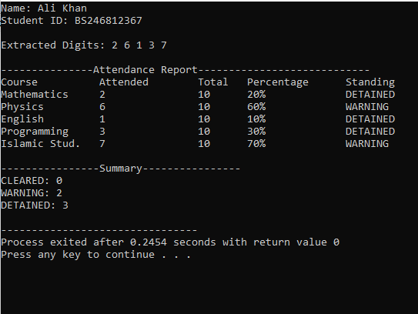

Syllabus:
The syllabus for this assignment includes all topics covered in lecture no. 1 to lecture no. 9.
Note: Remember that printf and scanf are not allowed. if you use it in the program, your marks will be deducted.
Best of luck!

